Ques1: Write a program for searching strings for the first occurrence of a character or substring and for the last occurrence of a character or substring.

Source Code

**package** Lab9;

**public** **class** FirstAndLastIndex {

**public** **static** **void** main(String args[]) {

System.***out***.println("Hitendra Sisodia");

System.***out***.println("500091910");

String s = "This is demo";

String str = "is";

System.***out***.println("String: "+s);

System.***out***.println("Search subsstring: "+str);

System.***out***.println("First occurance: "+s.indexOf(str));

System.***out***.println("Last occurnace: "+s.lastIndexOf(str));

}

}

Output

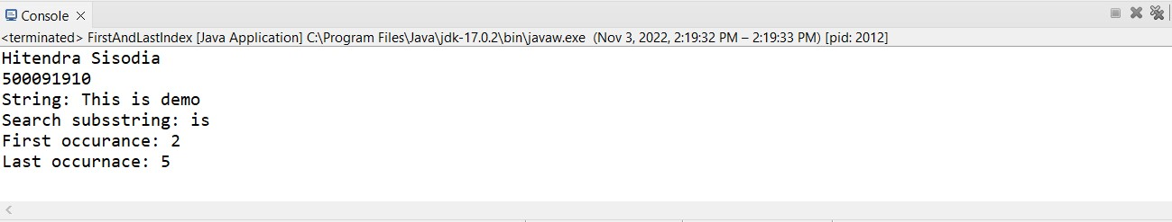

Ques2: Write a program that converts all characters of a string in capital letters.

Source Code

**package** Lab9;

**public** **class** UpperCase {

**public** **static** **void** main(String args[]) {

System.***out***.println("Hitendra Sisodia");

System.***out***.println("500091910");

String str = "Introduction to java Programming";

str = str.toUpperCase();

System.***out***.println(str);

}

}

Output

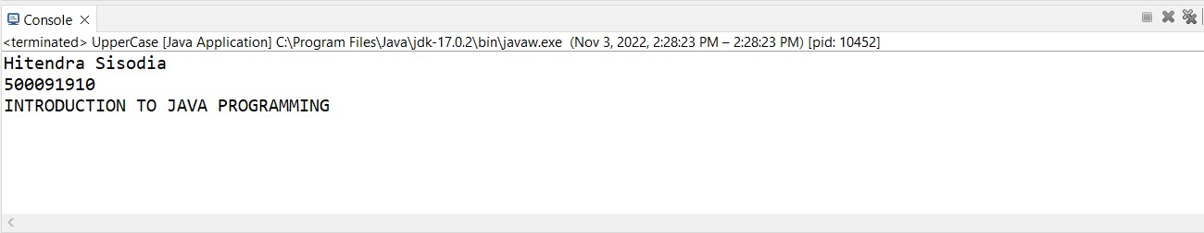

Ques3: Write a program in Java to read a statement from console, convert it into upper case and again print on console. (Don’t use inbuilt function).

Source Code

**package** Lab9;

**import** java.util.*;

**public** **class** UpperCaseWithoutInbuiltFunction {

**public** **static** **void** main(String args[]) {

System.***out***.println("Hitendra Sisodia");

System.***out***.println("500091910");

Scanner sc = **new** Scanner(System.***in***);

System.***out***.print("Enter String: ");

String str = sc.nextLine();

**int** size = str.length();

**char** arr[] = str.toCharArray();

**for**(**int** i = 0; i < size ; i++) {

**if**(arr[i] >= 'a' && arr[i] <= 'z') {

arr[i] -= 32;

}

}

String newstr= "";

**for**(**int** i = 0; i < size ; i++) {

newstr += arr[i];

}

System.***out***.println(newstr);

}

}

Output

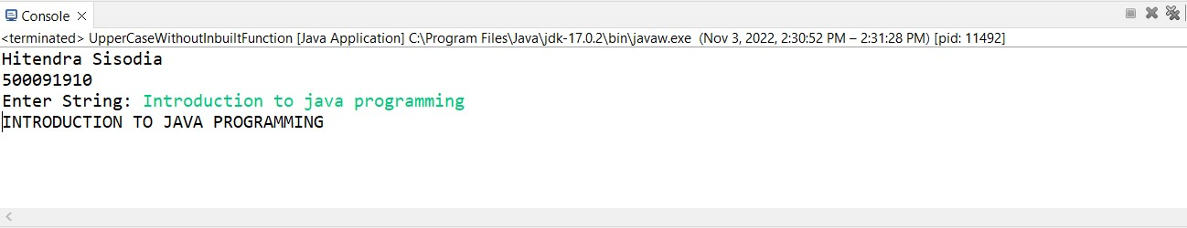

Ques4: Write a program in Java to create a String object. Initialize this object with your name. Find the length of your name using the appropriate String method. Find whether the character ‘a’ is in your name or not; if yes find the number of times ‘a’ appears in your name. Print locations of occurrences of ‘a’ .Try the same for different String objects.

Source Code

**package** Lab9;

**import** java.util.Scanner;

**public** **class** StringObject {

**public** **static** **void** main(String args[]) {

System.***out***.println("Hitendra Sisodia");

System.***out***.println("500091910");

System.***out***.print("Enter your name: ");

Scanner sc = **new** Scanner(System.***in***);

String str = **new** String();

str = sc.nextLine();

**int** size = str.length();

System.***out***.println("Length of name is: "+size);

**int** occurance = 0;

**char** arr[] = str.toCharArray();

**for**(**int** i = 0 ; i < size ; i++) {

**if**(arr[i] == 'a') {

occurance++;

System.***out***.println("char a spoted at: "+i);

}

}

System.***out***.println("Total No of occurnace of char a is: "+occurance);

}

}

Output

